**Gracious Germents**

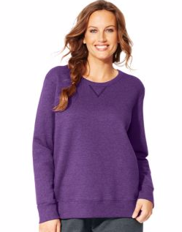

**DESCRIPTION:**

Hanes Women's Ugly Christmas Fleece Sweatshirt:

Midweight 50% cotton / 50% polyester fleece

Roomy, relaxed fit allows for easy layering.

Stretchy mini-rib trim finishes cuffs and hem.

Fun and frivolous Holiday graphics.

All the comfort of Hanes with our famous tag-free collar!

Machine wash cold with like colors, inside out if decorated. Use only non-chlorine bleach when needed. Tumble dry low. Cool iron if needed. Do not iron decoration.

Units Per Pack: 1

Country of Origin: Imported

**ADDITIONAL INFORMATION**

Weight: 0.5 kg

Dimensions: 10 × 8 × 3 cm

Size: S, M, L, XL,

Price: $20.00